Week 8 Individual Logbook
Capstone project
Matt Baker
2026
Table of Contents
Hours Breakdown 2
Completed Content/Documentation 3
Team Meetings 3
Advisor Meetings 3
Client Meetings 3
Research 3
Documentation 3
Development 3

Hours Breakdown
Category | Hours completed
Team meetings
Client meetings
Advisor meetings
Research
Development
Testing
Documentation
Logbook preparation | 1 hr
Sick leave/specific conditions
Other
Total Hours for this week
Running total of hours completed for  Capstone | 0/450hrs

Completed Content/Documentation

Team Meetings
Monday, August 31st
12:00 – 12:30PM (30mins)
Assigning roles to tasks I commented into the proposal doc, discussing hours, team schedule for today, creating an agenda.
Advisor Meetings
Monday, August 31st
10:00AM-12:00PM (2hrs)
Meeting with Bryce, going over the proposal, discussion of design science integration, his previous experience with it. Positives and negatives of Gantt charts.
Tuesday, September 1st
9:00 -9:45AM
Meeting with Bryce, final look over the proposal.

Client Meetings

Research

Documentation
Monday, August 31st
9:30-10:00PM (30 mins)
Added a reference to the DSR explanation in the proposal, sorted all the pages, added the updated in line page references, deleted 8 comments to remove the dead zone to the right of the pdf when it converts to show to Bryce.
1:00-3:00 (2hr)
I fixed the referencing in the proposal document to include retrieved dates in the cases of website documents. Replacing instances of “we are looking for” to “we are investigating”. I also wrote a separate section on why we selected DSR.
7:00 – 8:15 (1hr 15mins)
Completing the appropriated DSR diagram for Olivia, added figure references and description.
Tuesday, September 1st
9:45 –
Touching up proposal
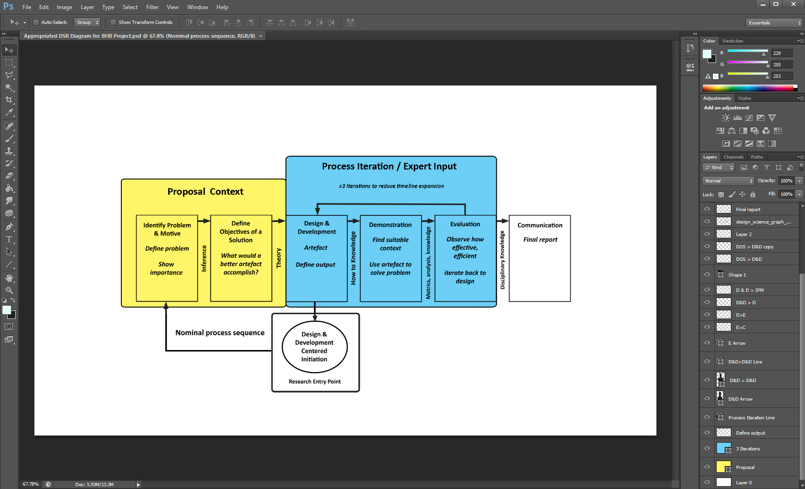

Testing
Monday, August 31st
5:00PM-6:30PM (1hr 30mins)
Experimenting with feeding different file types into Ollama based models, with the intention of simulating the processing of Foremost’s output. Part of this time was figuring out that E01 files need to be converted to .dd or .raw files before being processed by Foremost. To do this you use “libewf”. An E01 image is an Expert Witness Format (EWF). I ended up experimenting and conducting deep forensic analysis on a particular image.

Installing libewf
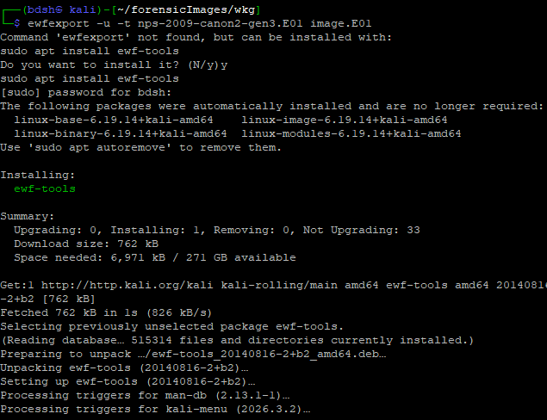
Using Libewf command (1) to convert the E01 to a raw “foremostable” file (2). Using foremost to file carve this forensic disk image (3), retrieving the output (4) which includes jpg files that I will have the AI examine (4,5).
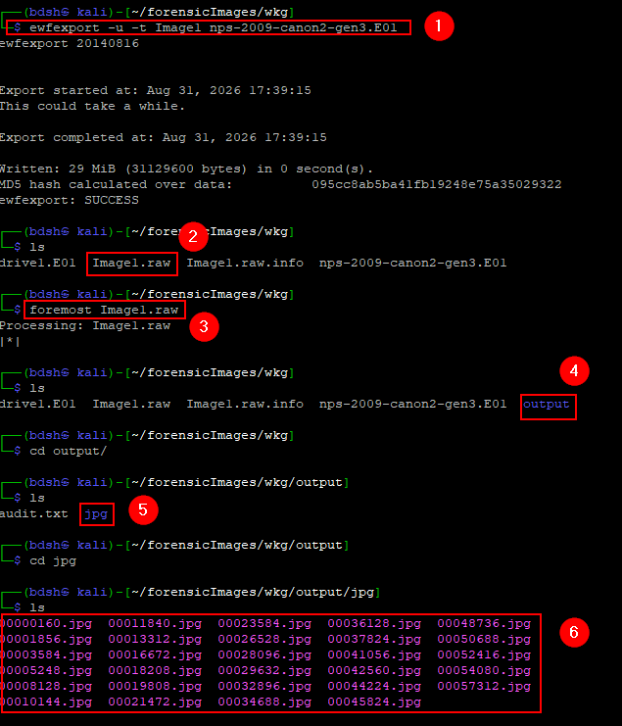

The AI is able to tell the manufacturer/model of computer present in the image(4), the potentially forensically relevant data within the image such as time, and date(2,3), and location (1). In a sea of images, this could potentially signal an incredibly useful tool to quickly summarize, consolidate, and cross reference other case-relevant data.
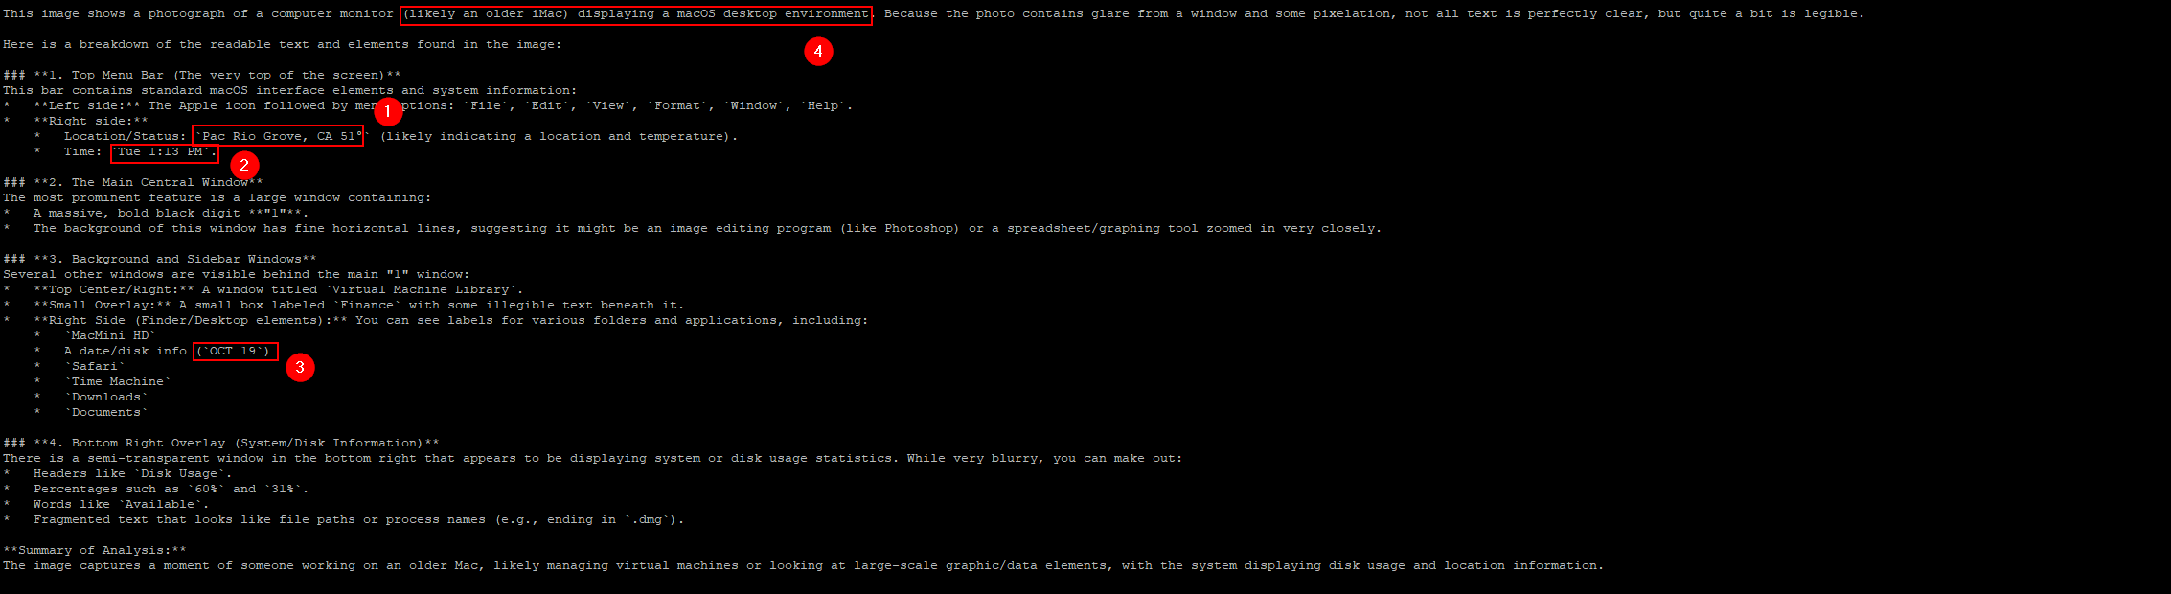
I sent the original jpg back to my Windows PC via SFTP, there is still some information it didn’t pick up on that I was able to identify, the directories and usernames for example. It was good that it did not present the name of the disk with the actual date the photo was taken.
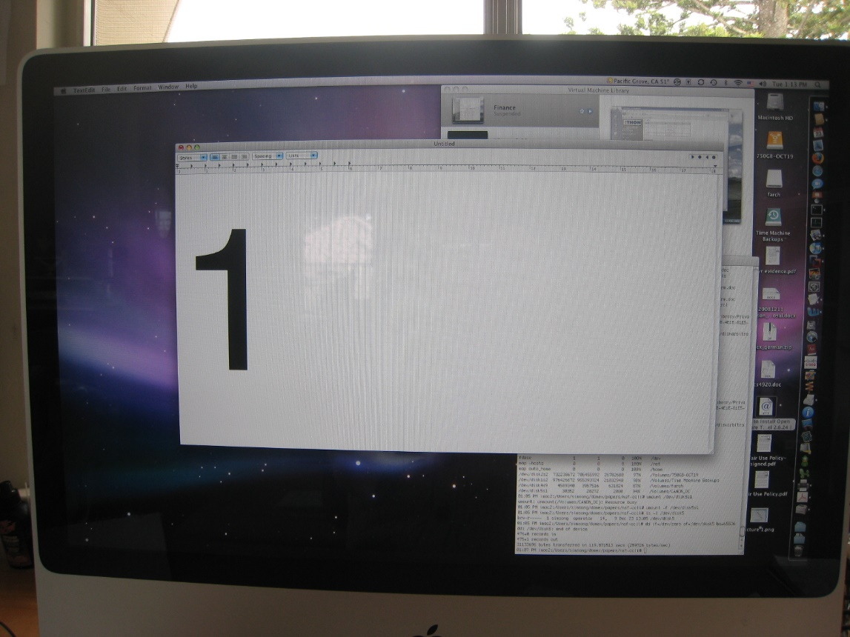
Exiftool reveals different times and dates than presented
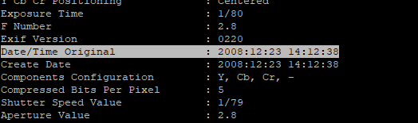

This timestamp for an ls-l command in the command line, was not picked up by the AI, but appears to show a more accurate date (23rd December, 1:05PM).
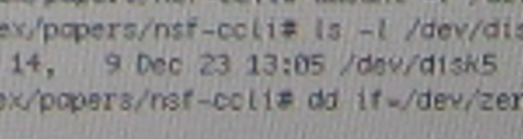

Development

